**Installing Ionic**

Contents

Install NodeJS 2

Install Cordova 6

Android 8

Install Java Development Kit (JDK) 8

Install Android SDK 11

Install Android SDK Packages 15

Create an Ionic App 17

# Install NodeJS

1. Goto <http://ionicframework.com/getting-started/>
2. Follow Link to <https://nodejs.org/en/>
3. Download V4 of NodeJS

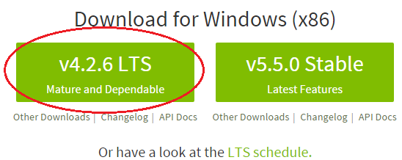

1. Click on the NodeJS file just downloaded to install it

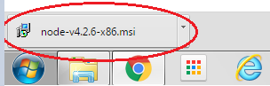

1. If presented with a Security Warning - just click Run

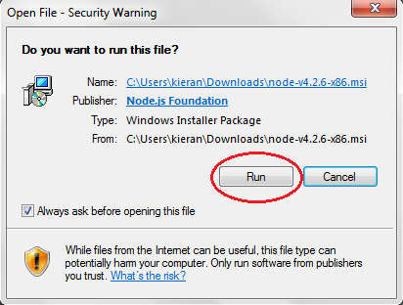

1. Click Next on NodeJS Setup Window

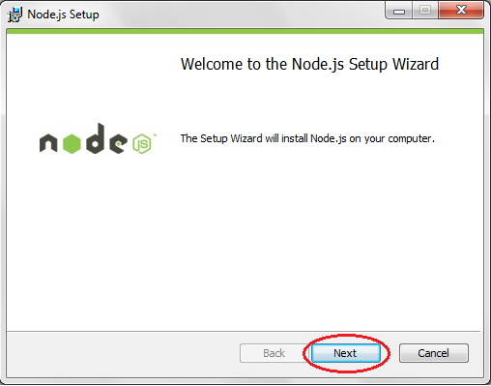

1. Accept the License and Click Next

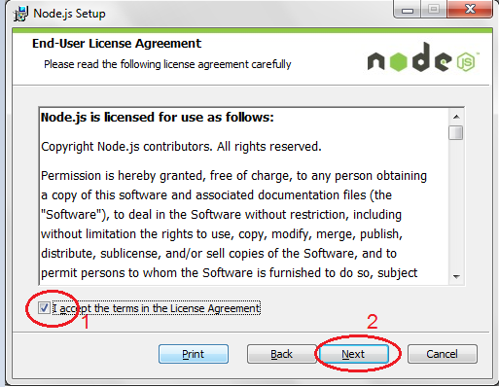

1. Choose a Destination Folder (or accept the default) and press Next

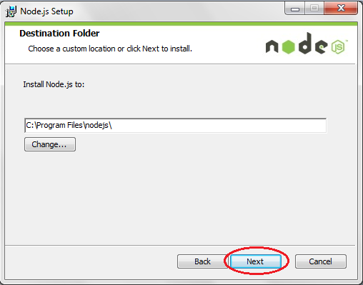

1. Select Node.js runtime (the default) and press Next

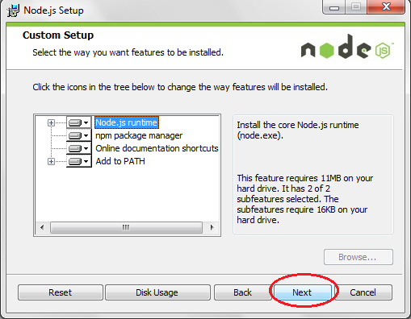

1. Press Install

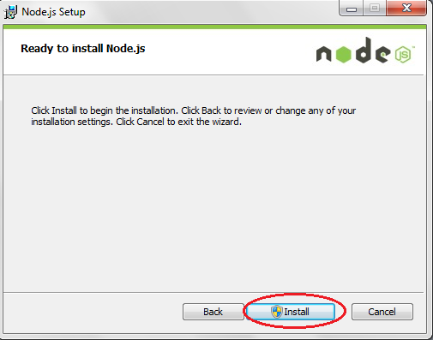

1. Press Finish to confirm installation of NodeJS

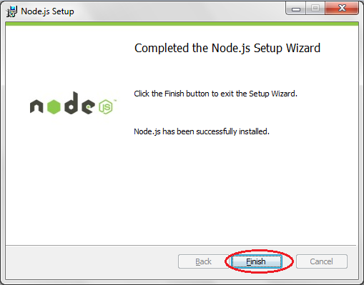

# Install Cordova

1. Click the 'Start button'
2. In the Search box type in cmd and press Enter

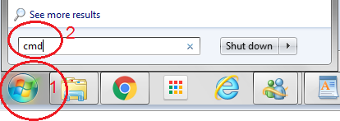

1. When the Command prompt appears type in the following:

npm install -g cordova ionic

and press Enter

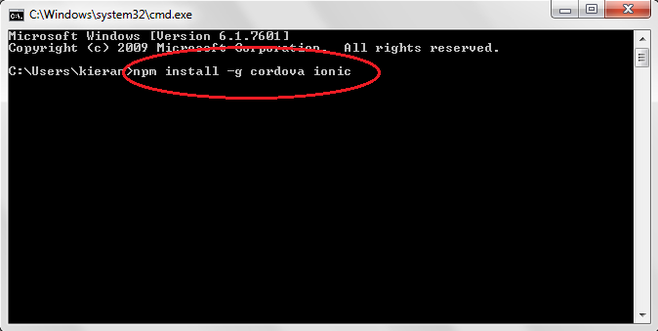

1. Successful installation of Cordova will look something like:

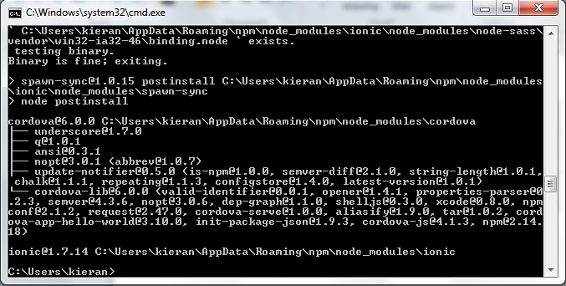

# Android

## Install Java Development Kit (JDK)

1. To determine which OS you have click this link: <https://support.microsoft.com/en-ie/kb/827218>

If you are running a 32-bit OS download Windows x86

If you are running a 64-bit OS download Windows x64

From <http://www.oracle.com/technetwork/java/javase/downloads/jdk7-downloads-1880260.html>

Accept the License Agreement and download the correct version of the JDK

1. Click on the JDK file just downloaded to install it

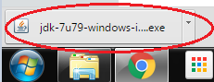

1. If presented with a Security Warning - just click Run
2. Click Next on the JDK Setup

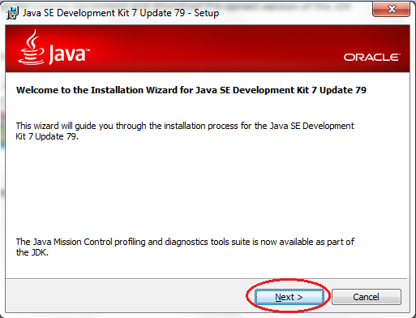

1. Development Tools is selected by default, Click Next

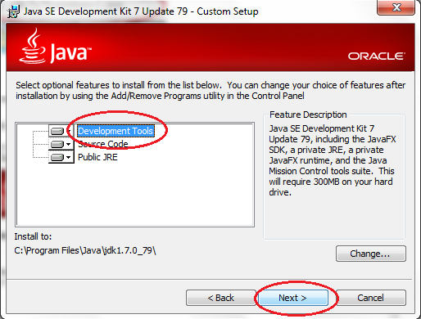

1. Accept the default destination folder, and click Next

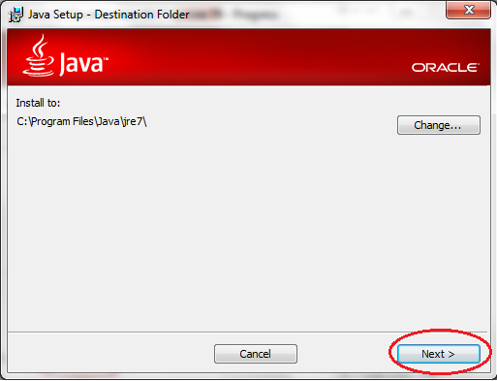

1. Click Close when installation is complete

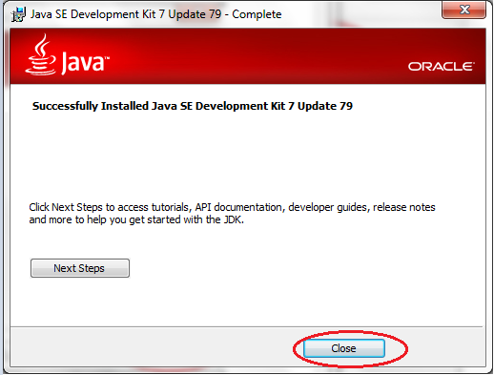

1. Set the JAVA_HOME Envrionment variable to C:\Program Files\Java\jdk1.7.0_75 as described in <https://confluence.atlassian.com/doc/setting-the-java_home-variable-in-windows-8895.html>

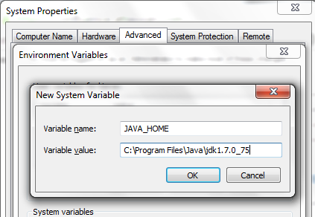

## Install Android SDK

1. Go to <http://developer.android.com/sdk/index.html#Other> and download the following file:

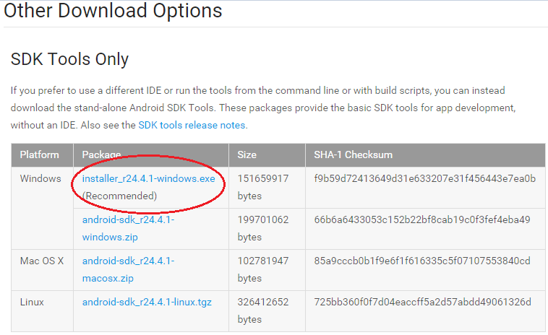

1. Click on the SDK file just downloaded to install it

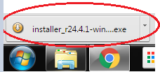

1. Click Next to Start the Setup Wizard

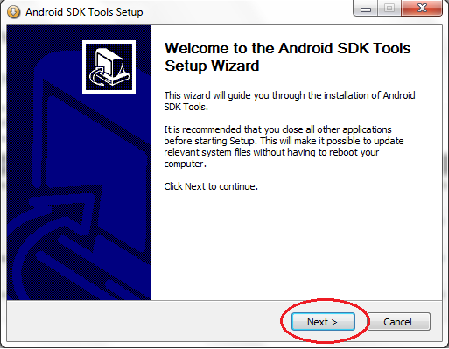

1. Click Next

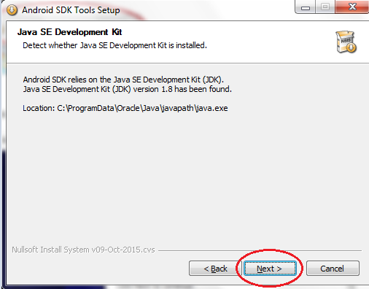

1. Click Next

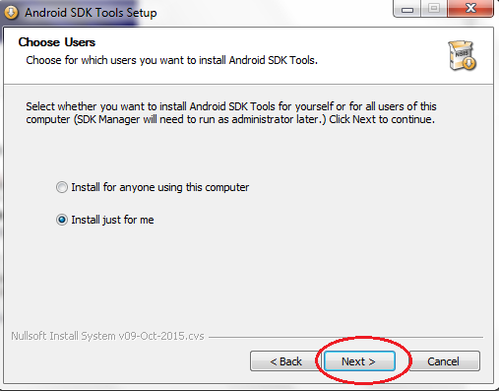

1. Click Install

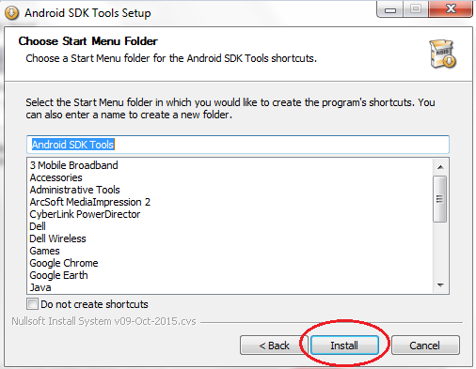

1. Click Next

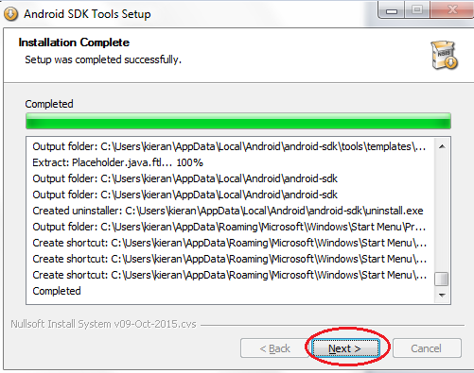

1. Click Finish

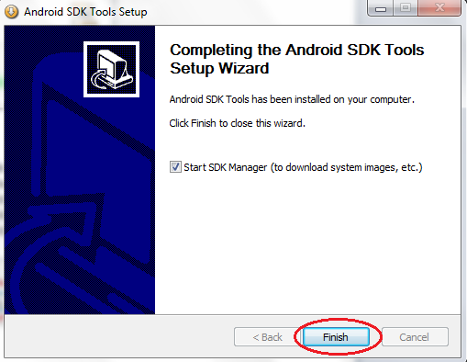

## Install Android SDK Packages

1. When the SDK Manager starts select the following packages (usually selected by default)

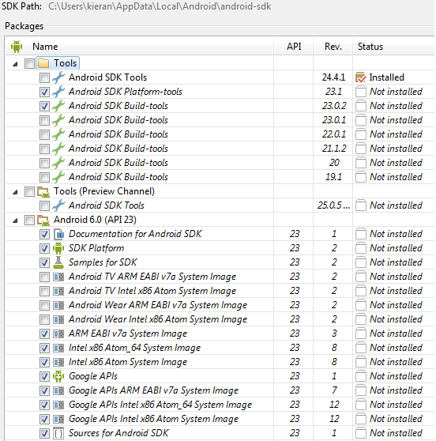



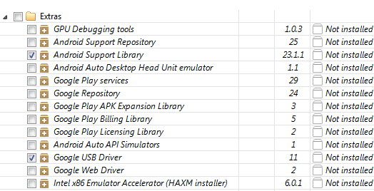

1. Press Install xx Packages

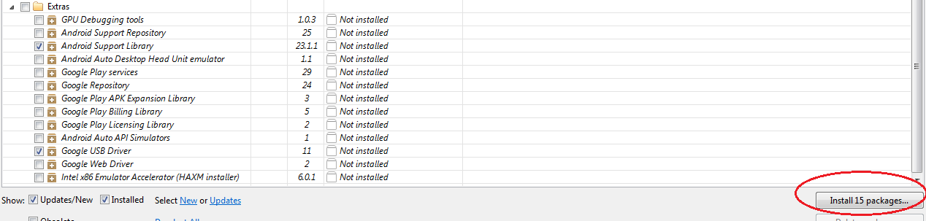

1. Accept License and Install

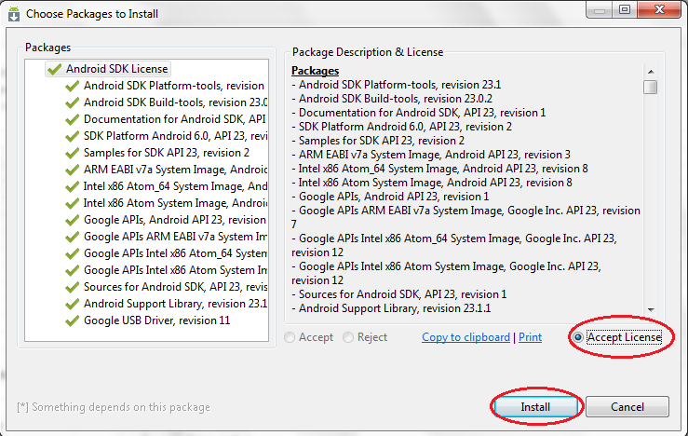

1. When Installation of SDK finished click Close

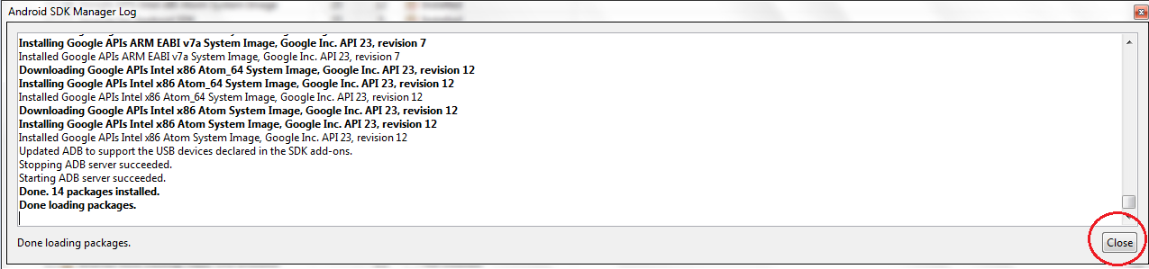

# Create an Ionic App

1. Make a new folder. Open the command prompt. Navigate to the folder and type

ionic start myApp tabs

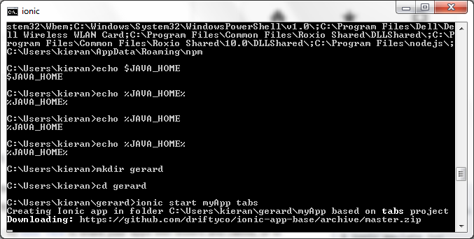

1. Press Enter at the following question

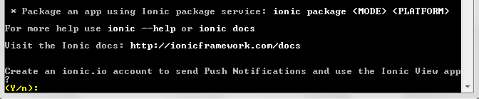

1. Go into the directory of the app you just created (myApp)

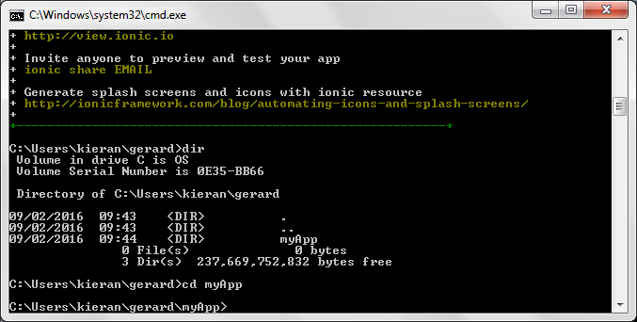

1. Type ionic serve to start the app in your browser

If asked to choose an address to use, choose 2 localhost

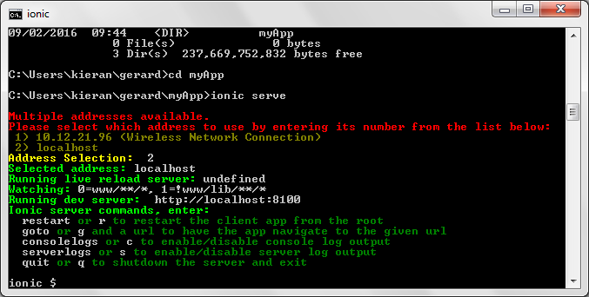

**NOTE**: When building an Ionic app, if the following error is shown:

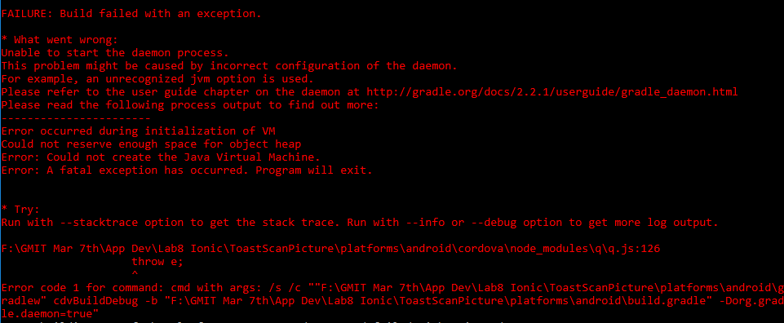

You should set a new Environment Variable as follows

GRADLE_OPTS

To

-Dorg.gradle.jvmargs=-Xmx512m

